**Name: Atharva Telrandhe**

**Branch & Sem: CSE-A IV Sem**

**Batch: A-2**

**Practical No. 4**

**Aim :**

**Code :**

**Sample1.html**

<!DOCTYPE html>

<html lang="en">

  <head>

    <meta charset="UTF-8" />

    <meta http-equiv="X-UA-Compatible" content="IE=edge" />

    <meta name="viewport" content="width=device-width, initial-scale=1.0" />

    <title>sample 1</title>

  </head>

  <body></body>

</html>

<script>

  let marks = Number(prompt("Enter your marks:"));

  if (marks >= 50 && marks <= 65)

  {

    console.log("Grade: C");

  }

  else if (marks >= 60 && marks <= 80)

  {

    console.log("Grade: B");

  }

  else if (marks >= 81 && marks <= 90)

  {

    console.log("Grade: A");

  }

  else if (marks > 90)

  {

    console.log("Grade: A+");

  }

  else

  {

    console.log("Invalid marks entered.");

  }

</script>

**Sample2.html**

  function removeDuplicates(array) {

    let uniqueArray = [];

    array.forEach((element) => {

      if (!uniqueArray.includes(element)) {

        uniqueArray.push(element);

      }

    });

    return uniqueArray;

  }

  const inputArray = [1, 2, 3, 2, 4, 5, 1, 6];

  const uniqueArray = removeDuplicates(inputArray);

  console.log(uniqueArray);

**Sample3.html**

  function countVowels(paragraph) {

    const vowels = ["a", "e", "i", "o", "u"];

    let vowelCount = 0;

    paragraph = paragraph.toLowerCase();

    for (let i = 0; i < paragraph.length; i++) {

      const character = paragraph[i];

      if (vowels.includes(character)) {

        vowelCount++;

      }

    }

    return vowelCount;

  }

  const paragraph = "The quick brown fox jumps over the lazy dog";

  const vowelCount = countVowels(paragraph);

  console.log("Number of vowels:", vowelCount);

**Sample4.html**

  function reverseNumber(number) {

    let reverse = 0;

    while (number > 0) {

      const digit = number % 10;

      reverse = reverse * 10 + digit;

      number = Math.floor(number / 10);

    }

    return reverse;

  }

  function isPalindrome(number) {

    const reverse = reverseNumber(number);

    return number === reverse;

  }

  const number1 = 12345;

  const number2 = 12321;

  console.log("Is", number1, "a palindrome?", isPalindrome(number1));

  console.log("Is", number2, "a palindrome?", isPalindrome(number2));

**Output :**

**Sample 1**

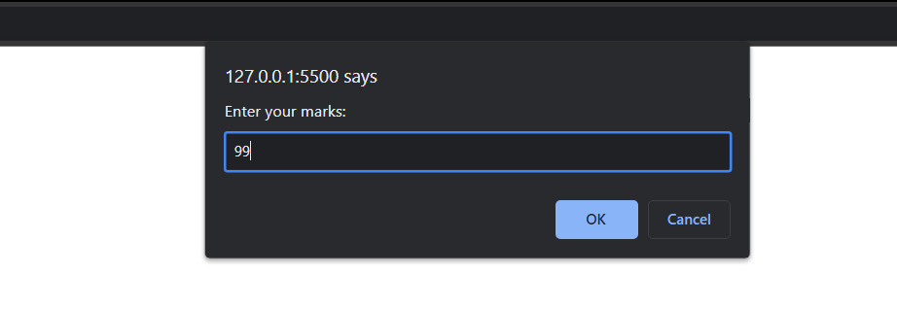 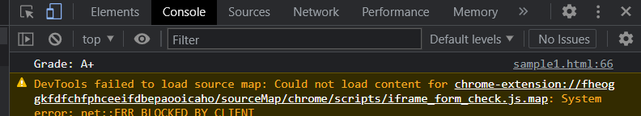

**Sample 2**

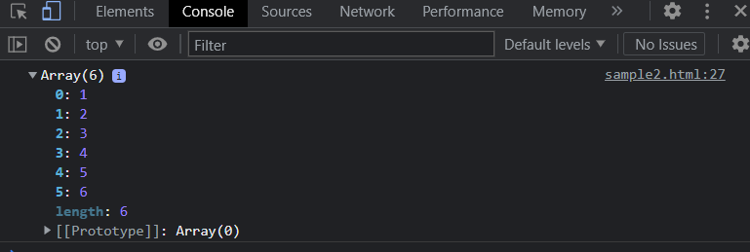

**Sample 3**

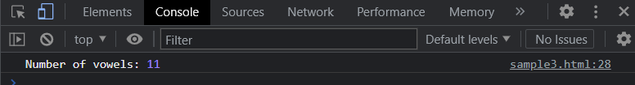

**Sample 4**

